
FMCA Spring Newsletter 2023
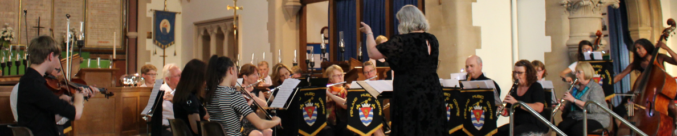

Dear FMCA members and supporters, thank you for continuing to support FMC!
We are having a push on fundraising during these next 2 years due to increased costs and a reduction in payment for engagements (organisations don’t have the money available to pay, or to pay much). It is difficult to get the right balance between keeping membership fees low and covering our costs and we will have a shortfall again this year. The FMCA committee are exploring ways to make ends meet, including applying for grants, advertising more and attracting new players, but we hope you can become more involved by encouraging others to join. Members, parents/carers, family and friends can help by:
Signing up for gift aid yearly on our registration forms. If you pay tax and are a player or parent of a player, FMCA can claim 25% tax on membership fees, which can help a lot towards running costs.
Signing up for Easy Fundraising (over 18) at www.easyfundraising.org.uk. FMC will benefit from a donation when you buy online from a list of over 7000 shops and services. Our set-up guide will soon be on the website or you can ask Jeremy for help during FMC sessions.
Tuck shop – The tuck shop is available between orchestra and concert band. The price of tuck has also increased and unfortunately, we have to pass those costs on. Please support FMCA by buying drinks and snacks during the break after orchestra, as any profits go toward our running costs. Thanks to all of the parents who run the tuck shop.
Promote FMCA events on your social media and by word of mouth in the following ways so that we can attract new members and people to come to listen to us - also encourage people you know to join if they have played orchestral instruments in the past, so that we can grow our membership.
Social Media - Please subscribe, follow and spread FMC news through your social media, so that more people know about us and join us. Check the website regularly for updates to information on FMC news, policies and engagements/concerts.
Website: www.fenlandmusiccentre.co.uk. Facebook: @fenland.musiccentre
Twitter: @Fenlandmusic Instagram: @fenland music
Photographs - If you take any photographs or video at FMC events, please could you email copies to us at fenlandmusiccentreassociation@gmail.com to use in our social media accounts, website and publicity and to add to FMC’s 50+ year visual archive. We will always check with permissions on the registration forms before posting or publishing any photos – we will use your photos on our social media if you send them in. Several embers have mentioned that they would like to see any photos members take and would like to share with everyone.
Tea Time Concert 18th March – please bring in cakes to sell at the Tea Time Concert. You can bring them to the FMC session on 17th instead if you wish. All baking is appreciated, thank you!
Term Dates
Spring term sessions: March 3rd, 10th, 17th & 24th
Summer term dates: April 21st & 28th, May 5th, 12th, 19th & 26th June 9th, 16th, 23rd & 30th & July 1st

Diary Dates _______________________________________________________________________________________
18th March Flute Day at St Peter’s Church – 12.30pm to 5pm
Tea Time Concert – Peterborough Flute Choir & Ensembles 6pm (see poster). Dress code for ensembles is casual.
21st April FMC returns for summer term.
23rd April St Georges Fair - time TBC - concert band only. Please arrive outside the library 10 minutes beforehand. We play for 20 minutes. Please remember to bring a stand, pegs and instrument. Casual dress.
30th April FMCA trustee meeting 6pm (documentation and finance report)
21st May AGM 6.30pm at St Peter’s Church. All members and parents/carers and supporters are welcome to hear a report on FMCA activities over the last year. Refreshments available. FMCA Committee meeting straight after the AGM (concert arrangements)
30th June Concert Practice 6pm onwards at St Peters Church & last FMC session of the summer term.
1st July Rotary Concert 7pm at St Peters Church. Concert dress – all black with brightly coloured tie/scarf or white top and black trousers, skirt & shoes. Help from friends/family members is appreciated on the door or selling raffle tickets or helping with refreshments.
2nd July Bandstand Concert 2pm-4pm at West End Park
15th Sept FMC Autumn term begins.
2nd Dec Chatteris Lights - 3.45 to 4.30pm Brass Band only – dress for weather and with festive decs
2nd Dec Xmas Concert 7pm at St Peter’s Church
3rd Dec *possibly playing at March Xmas Fair
8th Dec St Peter’s Christmas Fair - 6 to 8pm depending on group playing order
Please tell Beth or Ceri if you are unable to play on any dates, as soon as you know.
_____________________________________________________________________________________
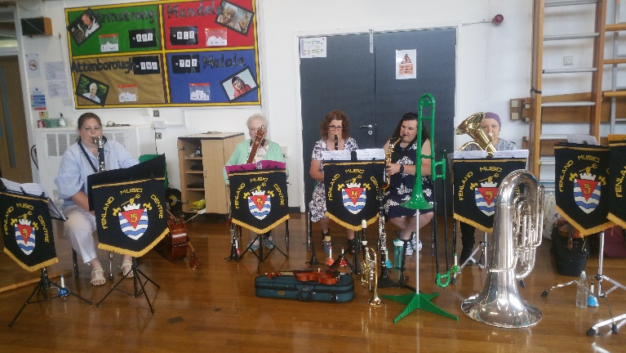
GNRD - ‘The Great Nursery Rhyme Disaster’
During May, June and July 2022, several FMC volunteers went into more than 10 primary schools in Fenland to introduce a range of orchestral instruments to children in outreach sessions.
It was very successful, and we hope to do a similar project next summer.
Many thanks to Sophie Megicks for the following photographs!
Christmas Concert - 3rd December 2022
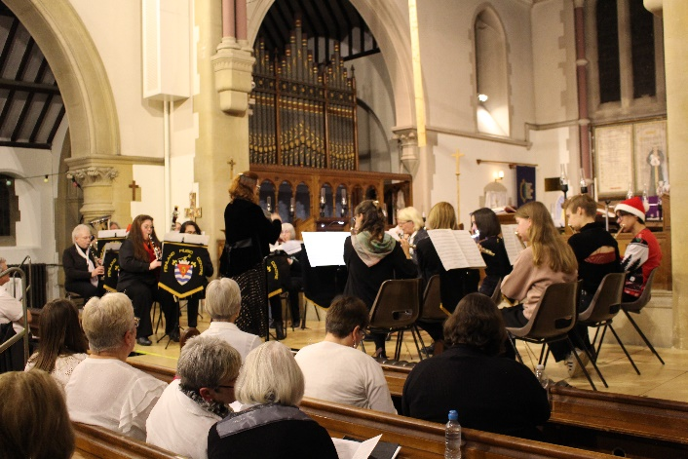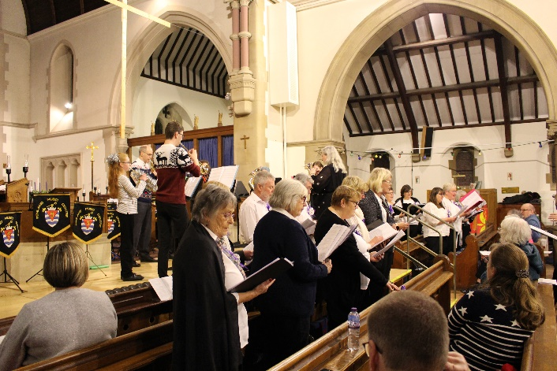
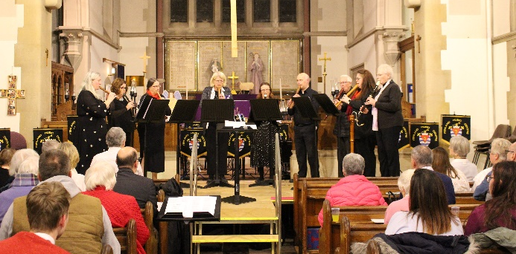
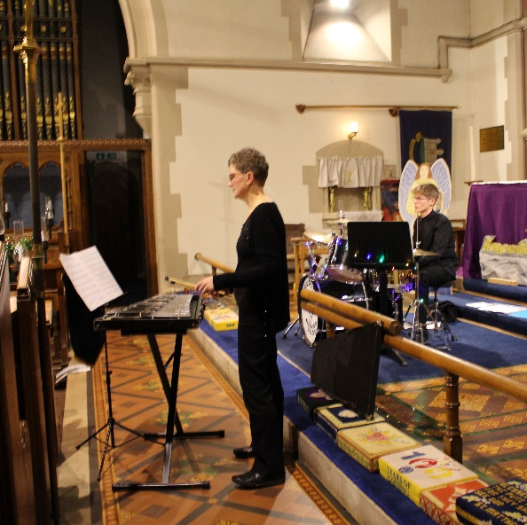
.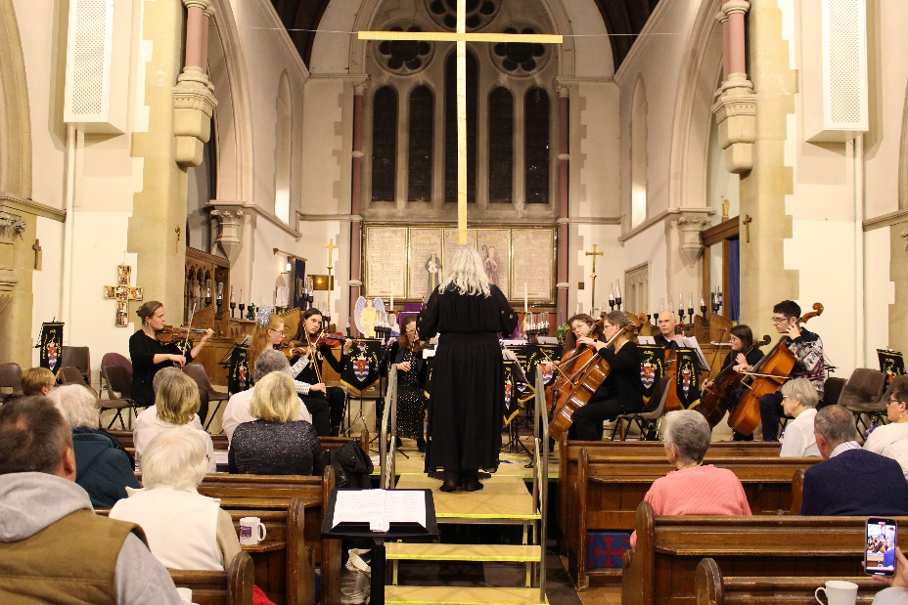
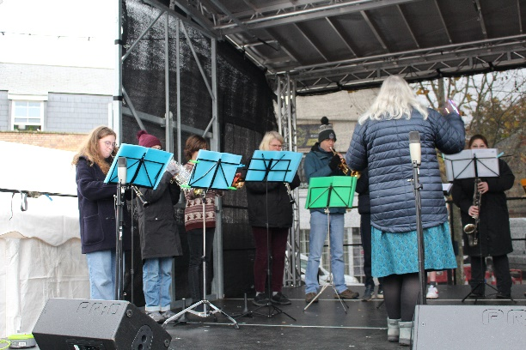
March Christmas Market
4th December 2022
Concert Band

St Peter’s Christmas Tree Festival - 9th December 2022
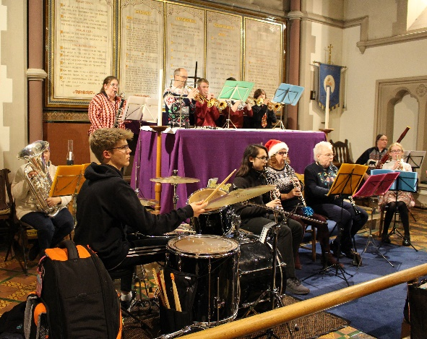
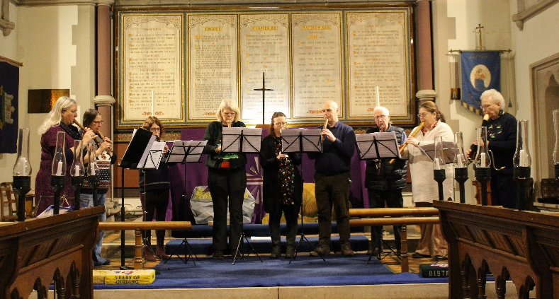
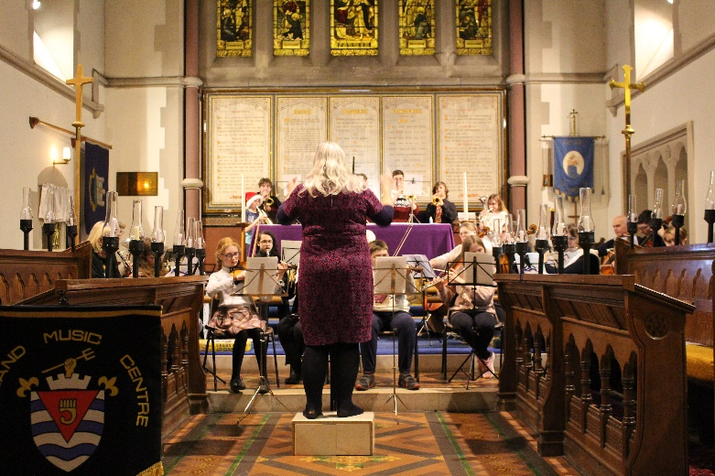
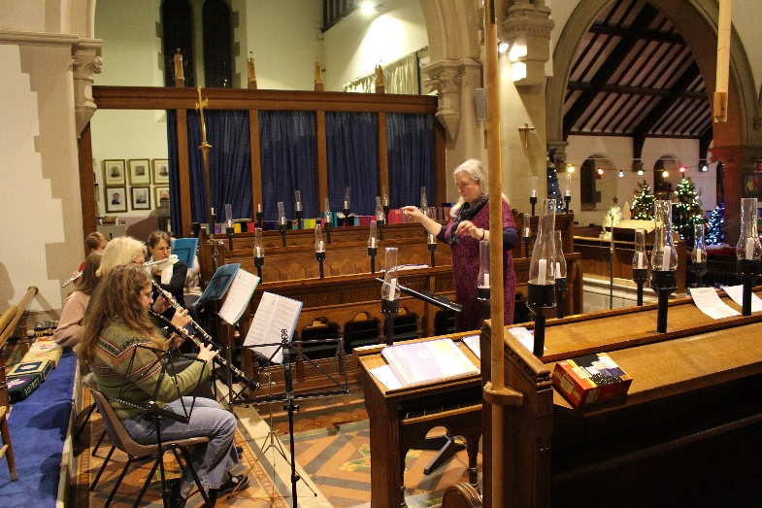
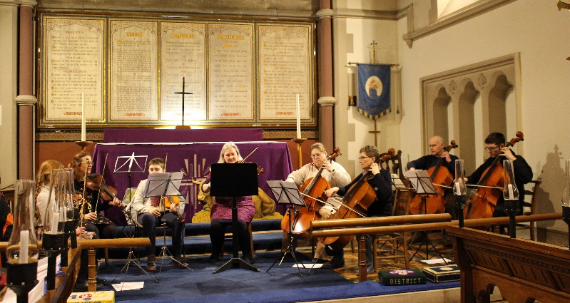
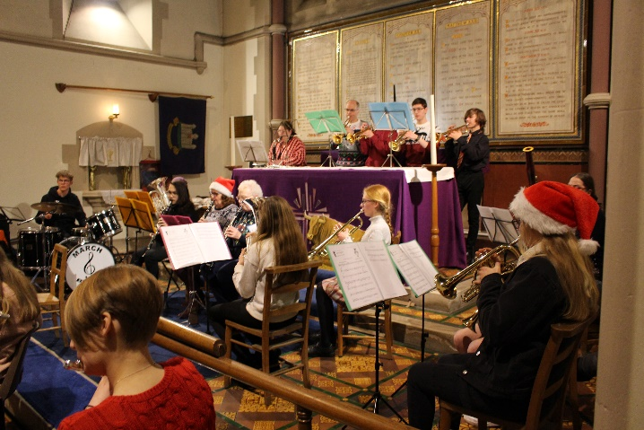

Please share your FMC photos via email to fenlandmusiccentreassociation@gmail.com

